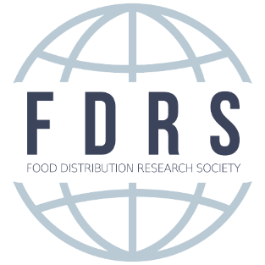
Doug and Anne Richardson Engagement Award
For Research on Food Distribution and Marketing Issues

Brand new in 2020, the Food Distribution Research Society (FDRS) seeks applicants for the Doug and Anne Richardson Research and Engagement Award, which are awarded to those individuals who conduct research and author papers focused in topics unique to issues related to food distribution and marketing. Award applicants must be early career colleagues employed at 1890 and 1994 Universities, no more than 5 years beyond earning their terminal degree.

Doug and Anne Richardson Research and Engagement Award
- One travel stipend ($1,500)
- Complimentary annual FDRS membership for one year
- Complimentary conference registration fees and recognition at the 2020 FDRS Annual Conference Awards Banquet
- Award recipients will present their Research Report during the Concurrent Sessions offered during the 2020 FDRS Annual Conference
Award Application Steps
- Statement of Intent form
- Submit a proposal in response to the Call for Research Reports (must be selected by the VP Research for inclusion in the Concurrent Sessions.)
- Cover letter that includes a brief synopsis of academic training, any food industry experience, and/or research experience and career interests and goals.
- Letter of recommendation from your department head and/or college dean.
- Applicants are limited to applying only once and subsequent submissions will be not be considered
- Only one submission will be accepted per university each year
- Applications are due by June 1, 2020

For more information contact FDRS’s Vice President of Research:

Dr. Lurleen Walters at LWalters@ufl.edu

