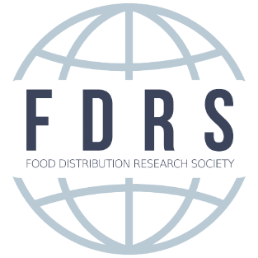

Richardson-Applebaum Outstanding Graduate Research
on Food Distribution and Marketing
Statement of Intent Form

Please complete the fields below and return this form, along with all other application materials, to Dr. Kathy Kelley via email at KathyKelley@psu.edu. To be considered for this award, please be sure that you submit all of your application materials as one PDF file in the following order by January 1, 2020. When labeling your PDF files, please include your first and last name and name of your university.
  - Statement of intent form
  - Cover letter that includes a brief synopsis of academic training, any food industry experience, and/or research experience and career interests and goals.
  - Letter of recommendation from the research advisor.
  - A copy of the dissertation/thesis/case study

Your name:

University/college affiliation:

Mailing Address:

Phone number:

e-mail address:

Award category for which you are applying (check one):
- Best Ph.D. Dissertation | - Best M.S. Thesis | - Best M.S. Case Study

Graduation date (must be between January 1, 2019 and December 31, 2019):

Title of submission:

Advisor(s):

PRIOR TO submitting your application, please complete the checklist below:
- Does your paper fit within the criteria of research in the area of food distribution and marketing? Broadly defined, this area encompasses all economic functions that occur between the farm gate and final consumer.
- Have you thoroughly proofread your paper?
- Are you submitting your application materials as one PDF in the order listed above?

